**PQE Report**

**Studying the translational interaction between the EV-A71 virus and its host cell**

Shawn Lee Ming Yang

Contents

Abstract

1. Introduction
   1. Hand, Foot and Mouth Disease (HFMD) and Enteroviruses
   2. The mechanism of EV-A71
   3. Ribosome profiling as a tool to investigate translation
   4. RNA-protein interactions to identify important host factors
2. Approach
   1. Studying the translation of EV-A71 and host cells
      1. Cold Synchronised infection
      2. Immunofluorescence
      3. Growth Kinetics
      4. Western Blot
      5. Quantitative Real Time-Polymerase Chain Reaction (qRT-PCR)
      6. Ribosome Profiling and Library Preparation
      7. Bioinformatics Analysis
3. Preliminary results
   1. Translational studies on EV-A71 and host
      1. Synchronised infection of RD cells
      2. Selection of timepoints
      3. General analysis of ribosome profiling data
      4. Preliminary search for hits
4. Future Work
   1. Analysis of results following improved library preparation
5. References

Abstract

Enterovirus A71 (EV-A71) is one of the major causative agents of Hand, Foot and Mouth Disease (HFMD), a disease endemic in Singapore. As a positive sense, single-stranded RNA virus, it relies heavily on the hosts’ processes for its replication, including the process of translation. In order to understand key factors involved with viral RNA translation, Rhabdomyosarcoma (RD) cells are first infected with the EV-A71 virus using a cold synchronised infection method, and ribosome profiling and RNA-seq are used to study the changes in the translatome and mRNA abundance at specific timepoints. For a start, some of the key factors involved in various translation processes were looked at. As the infection progressed, some categories such as transcription factors became enriched in our Gene Ontology (GO) analysis, suggesting a link between these proteins during the viral infection. At the same time, experiments are ongoing to try to pull down host factors that associate to the viral RNA after the viral RNA has been introduced into the cell. Current methods tried include using a biotin-streptavidin method, as well as a method that makes use of the natural interaction between the MS2 coat protein and RNA hairpin loop. Moving forward, a closer look at other known important host factors is required, as well as a further investigation of how DNA-interacting factors are important in the viral replication process.

1. Introduction

1.1 Hand, Foot and Mouth Disease (HFMD) and Enteroviruses

Hand, foot, and mouth disease (HFMD) is a typically mild and self-limiting condition, usually affecting infants and children below the age of 5 (Wang et al., 2013; Zhao et al., 2016). Affecting approximately 33,000 children in 2017, HFMD is a disease endemic in Singapore (MOH, 2018). Several outbreaks of this disease have also occurred around the region in recent years, including India (Sasidharan et al., 2005; Kar et al., 2013), Hong Kong (Ma et al., 2010), Malaysia (Hooi et al., 2002), Taiwan (Chang et al., 1999), Japan (Momoki, 2009; Miwa et al., 1980) and Korea (Baek et al., 2011). This disease is primarily caused by enteroviruses, namely Enterovirus A71 (EV-A71) and Coxsackievirus A16 (CV-A16) (Wong et al., 2010). While the usual manifestations of this disease are ulcers on the hands, feet and in the mouth that subside in about a week, HFMD caused by EV-A71 may result in various forms of neurological complications (Huang et al., 1999; Alexander et al., 1994; Hayward et al., 1989). Although there are three vaccines that have been developed for use in China against EV-A71, none of them have been approved for use in Singapore (Yi et al., 2017). Due to the high occurrence of this disease and a lack of a suitable mode of treatment, there is a need to understand the underlying mechanism of the disease, and identify potential treatments for it.

Enteroviruses are positive sense, single-stranded RNA ((+)ssRNA) viruses that belong to the P*icornaviridae* family (Zhou et al., 2011). These viruses are non-enveloped, with a genome of approximately 7.4kb. When the RNA is translated, the product made is a polyprotein consisting of capsid proteins and non-structural proteins. Since the full genome is a single strand of RNA, the virus tends to have a high mutation rate due to the proposition of errors in its genome caused by the error prone nature of the RNA-dependent RNA polymerase (RdRP) (Meng & Kwang, 2014; Wu et al., 2010). This rapid generation of viral variants also causes the generation of therapeutics targeting the viral RNA to lose its effectiveness rapidly. Hence, besides looking at the genome of the virus to find targets for treatment, there is a need to look at the interaction between a virus and its host cell. By targeting factors that the virus relies on when undergoing replication in the host, it is more likely to withstand any changes that might occur in the virus, making it a more viable method of uncovering new therapeutics. In order to target the host factors, it is therefore important to understand the series of events that occur once the virus enters the host cell.

1.2 The mechanism of EV-A71

For the EV-A71 virus to infect a cell, it first needs to be internalised. This occurs via a process known as clathrin-mediated endocytosis (Lin et al., 2012; Hussain et al., 2011). For the recognition and uptake of the virus, two receptors have been identified, namely the human scavenger receptor class B2 (SCARB2) and P-selectin glycoprotein ligand-1 (PSGL-1) (Yamayoshi et al., 2014; Nishimura et al., 2009; Yamayoshi et al., 2009). Of the two receptors, SCARB2 is known to be the key entry receptor, where it interacts with the VP1 capsid protein of EV-A71 (Yamayoshi et al., 2009; Nishimura et al., 2009). After the virion is recognised by the receptor and brought into the cell, the capsid protein of the virion interacts with SCARB2 and the RNA is subsequently released into the cell via a process facilitated by the acidification of the endosome (Lin et al., 2013). Since the viral RNA is of the positive sense, it can directly undergo translation using the host cell’s translation machinery. For EV-A71, it is known to hijack the translational machinery of the host cell by facilitating the degradation of certain proteins needed during translation. These would include eIF-4E, a protein complex necessary for the cap-dependent translation of host mRNA. Since the EV-A71 virus undergoes translation using the internal ribosome entry site (IRES) located in the 5’ untranslated region (5’ UTR) of its RNA (otherwise known as cap-independent translation), the prevention of host mRNA translation and the continued translation of the viral genome via the 5’ UTR ensures that the bulk of translation in an infected cell is that of viral RNA. In addition, many other host factors have been suggested to be important for various steps of EV-A71 viral replication, including a class of host factors needed for IRES-dependent translation, known as IRES Trans-acting factors (ITAFs). Some of the more well-studied ITAFs include heterogenous nuclear ribonucleoprotein A1 (hnRNP A1), Polypyrimidine tract-binding protein (PTB) and Far-upstream element-binding protein 1 (FUBP1) (Shih et al., 2011).

While the translation of viral proteins is ongoing, the positive sense RNA is able to undergo transcription using one of the proteins being synthesised from the viral RNA, RNA dependent RNA polymerase (RdRP). RdRP is encoded in the viral RNA, and is necessary for the transcription of negative sense RNA from the positive sense viral RNA. This negative sense RNA is then used to make more copies of the positive sense viral RNA as part of the replication process of the virus within the host cell. With the translation of the viral capsid proteins and more copies of positive sense viral RNA being made, virions can be assembled inside the cell, forming new infectious particles. These assembled virions can then finally be released from the cell as the cells lyse, going on to infect new cells. These occur within a span of 10 to 12 hours.

Looking back at host mRNA translation, while most of it undergoes cap-dependent translation, there have been instances where host mRNA do make use of an IRES dependent translation, similar to that of viruses (Fitzgerald & Semler, 2009; Lopez-Lastra et al., 2005; Komar & Hatzoglou, 2011; Shatsky et al., 2010). This would mean that while the virus has degraded the proteins needed for cap-dependent translation, the cap-independent translation of host mRNA can still be done. Some genes that have been reported to undergo the cap-independent translation method in host cells include genes involved in stress response and mitosis (Komar & Hatzoglou, 2011; Pyronnet et al., 2000). However, whether these host genes associated with cap-independent translation are also important for viral replication as well remains to be elucidated.

1.3 Ribosome profiling as a tool to investigate translation

In order to study the translation of mRNA, a technique known as ribosome profiling can be used. This ribosome profiling strategy was developed by Nicholas Ingolia and Jonathan Weissman in 2009, and it relies on the sequencing of ribosome-protected fragments bound by translating ribosomes (Ingolia et al., 2009). By comparing the ribosome profiling results with RNA-seq data, the translation efficiency of a particular RNA can be determined, hence allowing the level of translation of genes to be compared. In a scenario where there are two conditions involved (e.g. infected and uninfected cells), the changes in the translational efficiency of specific genes can be compared. In fact, this technique has been used to study changes in translation of host factors in other viruses. This includes DNA viruses such as the human cytomegalovirus (HCMV) and Vaccinia virus, (+)ssRNA viruses such as Hepatitis C virus (HCV) and (-)ssRNA viruses such as the Influenza A virus (IAV) (Bercovich-Kinori et al., 2016; Dai et al., 2017; Colman et al., 2013; Yang et al., 2015). Changes in the translation of some of these mRNAs have been successfully characterised, including oxidative phosphorylation genes in cells infected by the Vaccinia virus, and translation-related genes in the aminoacyl-tRNA synthesis pathway, as seen in HCV-infected cells. In addition, the fact that some of these genes maintain similar translation efficiencies both before and after infection might be interesting as well. For example, the translation of ribosomal proteins and genes in the oxidative phosphorylation pathway remains constant both before and after IAV infection of cells. While this may be explained by a low turnover rate for ribosomal proteins (hence low translation for ribosomal proteins both before and after infection), it may not necessarily be true for proteins in the oxidative phosphorylation pathway (Popa-Wagner et al., 2018; Karunadharma et al., 2015).

While there is in depth research being conducted on the potential therapeutics of EV-A71, there is still work to be done when looking at the specific effects of the EV-A71 virus on translation in a host cell. Hence, to determine what translational changes are present in the host cell, the technique of ribosome profiling can be employed.

For the first aim of my project, I will be looking at the changes in translation profiles during an EV-A71 infection. To do this, Rhabdomyosarcoma (RD) cells will be infected, and the polysome profiles will be collected at various timepoints along this infection process. It is expected that as a result of the infection, a decrease in overall translation within the cell will be observed. By using the ribosome profiling technique, we may be able to see that some of the host genes remain translated at a constant rate, or that its translation increases, suggesting a possible role of these genes in viral replication. This effect will be verified, before a detailed investigation of the role in infection these genes play will be done.

Earlier this year, a paper was published where they used ribosome profiling and RNA-seq to look at the changes during an EV-A71 viral infection as well (Lin et al., 2018). In this paper, the authors used a similar methodology of synchronising the cells (but by saturation via a Multiplicity of Infection of 40) and collecting lysates at various timepoints, in an attempt to study changes in translation of both mRNA from viral and host origin. However, the authors did not reveal any information about specific changes in the translatome, and there also appears to be room for improvement in terms of the methodologies used. Hence, there is likely to be some more things that remain to be uncovered in terms of the translational interaction between the EV-A71 virus and its host cell.

1.4 RNA-protein interactions to identify important host factors

During the infection process of an EV-A71 virus, the virus relies heavily on host factors for its own replication, including entry and translation. This dependence on host factors indicates the need for some form of interaction between the viral components and host factors. Such host factors include the Scavenger receptor B2 (SCARB2) for viral entry and unpacking, as well as ITAFs hnRNP A1 and FUBP1. In order to identify more of such important host factors, the interactions between viral RNA and host factors has to be studied in greater detail.

As a positive strand RNA virus, the translation of its RNA to make the viral polyprotein is especially important for the EV-A71 virus, since it is needed to produce capsid proteins and various non-structural proteins essential for the synthesis of new virus particles. A study was previously conducted on the 5’ UTR of the viral genome, where the authors identified 12 cellular proteins that interacted with this part of the viral RNA. These include the ITAFs hnRNPA1, FUBP1 and FUBP2 (Lin et al., 2008). While these proteins bind to the viral RNA, the specific effects of these proteins also need to be studied. For example, while both FUBP1 and FUBP2 interact with the viral RNA, only FUBP1 results in an increase in the IRES activity. In contrast, when FUBP2 was over-expressed, a decrease in viral protein synthesis was observed.

Another key factor involved in translation is the ribosome. Made of ~80 ribosomal proteins and 4 ribosomal RNAs, the ribosome has the potential to exert certain regulatory functions on the cell. A small change in its composition may result in a difference in the specificity and function of the ribosome. In fact, certain ribosomal proteins have been identified as necessary for the translation, yet not causing a significant effect on the survivability of the cells. For example, for the Heptatitis C virus (HCV) and Cricket Paralysis Virus (CrPV), RPS25 has been found to be important for the binding of the ribosome to the IRES (Landry et al., 2009). For the Vesicular Stomatitis Virus (VSV), RPL40 is found to be necessary for the cap-dependent translation of its genome. Although RPL40 is dispensible for most of the cellular transcripts, some of them are selectively sensitive to it. Hence, these examples show the relevance of ribosome heterogeneity in affecting the translation of viral RNAs.

1. Approach

2.1 Studying the translation of EV-A71 and host cells

2.1.1 Cold Synchronised infection

To look at the translational changes during the EV-A71 viral infection, the mRNA would have to be collected from lysates. However, it is important to select specific timepoints that we want to collect these lysates from, ideally timepoints that have the greatest changes occurring during infection. Hence, various assays would need to be done to understand roughly what is going on with the cells throughout the infection. However, as the virions may enter the cells at any time during the infection process, the observed profiles may not be an accurate representation of cells at a specific stage of infection. Hence, there was a need to ensure that the virions entered the cells in a synchronised manner, and this can be done via a cold synchronised infection.

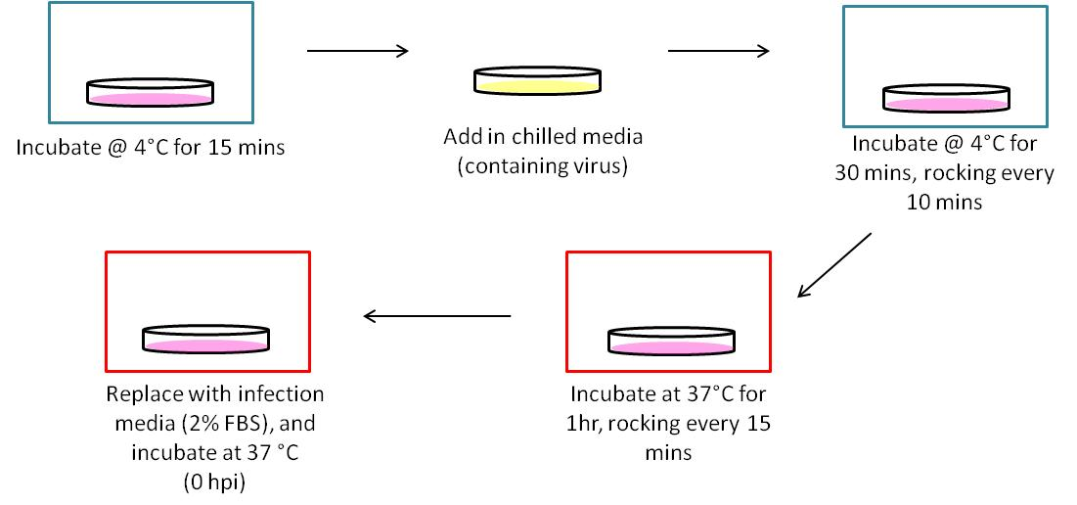

**Figure 1: Outline of cold synchronised infection protocol.**

Briefly, RD cells were seeded in a 15cm dish the day before infection to achieve a confluency of ~70-80%. A glass cover slip was put into the dish before the cells were seeded in order to obtain a sample of cells to be used for staining. To synchronise the infection, cells are pre-chilled at 4°c for 15 minutes. Next, chilled serum-free media containing the virus (to achieve an MOI of 10) is added to the cells, and incubated again at 4°c for 30 minutes, rocking every 10 minutes. The cells are then shifted back to 37°c for 1 hour, rocking every 15 minutes. Finally, the cells are rinsed with pre-warmed PBS to remove any remaining adherent virions, and low serum media (2% FBS) is added back to the cells before incubating at 37°c again.

2.1.2 Immunofluorescence

An immunofluorescence assay was used to follow the changes in amount of viral proteins present in the cell throughout infection. Prior to this, the cells are fixed with methanol either on a cover slip or in a 6 well dish, and stored in Phosphate Buffered Saline (PBS) at 4°c. To stain the cells, the PBS is removed and the cells are incubated with mouse α-VP2 (MAB979, Merck; 1:1000), diluted in PBS. The cells are kept in the dark, and rocked for 2 hours. Next, the cells are washed twice with PBS, and incubated with rabbit α-mouse (1:200) for 2 hours. The cells are washed again, before incubating for 15 minutes with Hoechst 33342 to stain for the nucleus. Finally the cells are washed again before visualising.

The Operetta and Columbus system (Perkin Elmer) was used to visualise the cells and to process the images respectively. While using the Hoechst stain to count the number of cells present, the VP2 stain was used to monitor the production of the viral proteins as the cell is being infected. The two values can then be used to follow the progress of infection.

2.1.3 Growth Kinetics

While the change in amount of viral proteins can be monitored using the immunofluorescence assay, it does not say anything about the production of infectious particles. Hence, to check for this, a growth kinetics plot was done. Briefly, a 15cm dish of cells is used for each timepoint. The cells are infected, and at each timepoint, the cells are frozen for 1 hour and left to thaw for 15 minutes. This is done for a total of 3 times, and the lysates are then collected to be used for a plaque assay. The number of plaques formed at each timepoint is then used to plot the growth kinetics curve, indicating the amount of infectious particles that can be collected from each timepoint.

2.1.4 Western Blot

Along with the immunofluorescence assay being done, a western blot was done to monitor the changes in the production of viral proteins collectively from a plate of cells. At the appropriate timepoint, cycloheximide (CHX, Sigma-Aldrich) was added to the cells for 10 minutes to stall the ribosomes. The cells are rinsed with PBS and then collected via scraping with lysis buffer. The cells are sheared with a 26G needle to break up the cell membrane even further, and the cytoplasmic lysates are collected after clarification. A Bradford assay was done to estimate the amount of proteins in the sample, and a 4-12% Bis-Tris Protein Gel is done. The gel probed for α-VP2 (1:5000) and rabbit α-mouse (1:10,000). Also as a loading control, anti β-actin (1:1000) and anti-rabbit (1:10,000) was used. Four bands are expected, due to way that the polyprotein is being synthesised and processed.

2.1.5 Quantitative Real Time-Polymerase Chain Reaction (qRT-PCR)

In order to follow the changes in amount of viral RNA in infected cells, primers for both the forward and reverse strand of the viral RNA were used. In addition, the primer for actin is used for normalisation. First, the lysates collected from each timepoint were treated with TRIzol LS and the RNA was precipitated accordingly, before the Reverse Transcription was done with M-MLV (Promega). The quantitative PCR was done with the CFX96 Real-Time PCR system (Bio-Rad) using the SsoFast EvaGreen Supermix (Bio-Rad). The experiment was done in triplicates.

2.1.6 Ribosome profiling and library preparation

After the timepoints have been decided on, lysates were collected (as described earlier) and snap frozen in liquid nitrogen until use. The lysates were then thawed on ice, and treated with optimised amounts of RNase I for 30 minutes at 4°c. For the first round of library preparation, 1, 6 and 9 hour post infection (hpi) were decided upon as the timepoints. This round of libraries would then provide some insight into the depth of sequencing required, the distribution of reads that would be obtained from the timepoints done (host v.s. viral reads), as well as any the requirement for further removal of rRNA in the RPF samples. For the second library preparation, the relevant changes are made, and more timepoints with smaller intervals are done to get a closer look at the changes during EV-A71 viral infection.

A linear sucrose gradient was prepared in a SW41 tube using 10% and 50% sucrose buffers (w/v). The digested lysates were layered over the sucrose gradients, and the sucrose gradient ultracentrifugation was done at 36,000rpm for 2 hours at 3°c. The gradients were then fractionated using the BioComp Gradient Station fractionator and the absorbance at 254nm was recorded. For the digested samples to be sequenced, the fractions corresponding to monosomes are collected and used for library preparation.

For total RNA, the lysates are collected (as described earlier), and treated with TRIzol LS. The samples are then processed with TURBO DNase and RNA Clean and Concentrate-5 (RCC-5) for the removal of DNA and small RNAs respectively. Next, the Ribozero kit is used to remove the ribosomal RNAs, retrieving the mRNA. Finally, the mRNA is fragmented into fragments of about 33 to 48 nucleotides via alkaline hydrolysis.

The libraries are then prepared accordingly. The steps for library preparation are summarised in Figure 2. Fragments of about 27 to 33 nucleotides for RPFs, and 33 to 48 nucleotides were obtained via the size selection gel, and used for the subsequent steps.

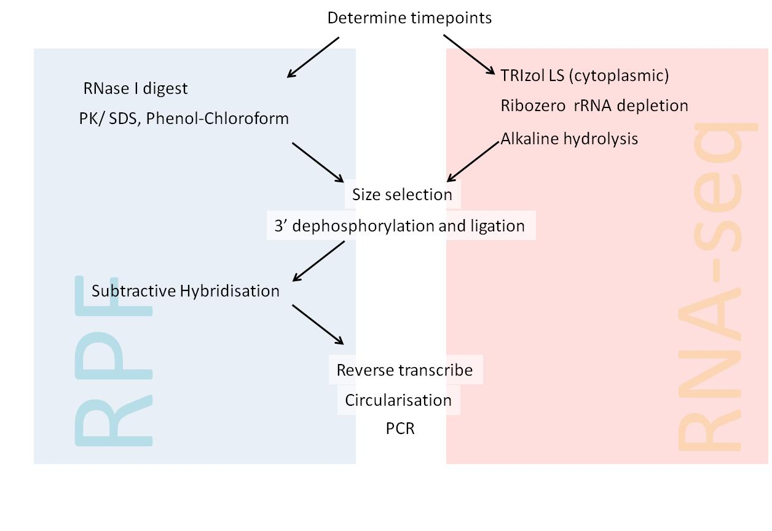

**Figure 2: Overview of library preparation for both Ribosome protected fragments (RPFs) and RNA-seq.**

2.1.7 Bioinformatics Analysis

With the sequenced reads from the library preparation, the results can then be used for the various analyses planned. The results returned will first be processed (trimming of adaptors, removal of rRNA and tRNA reads), before being mapped to the hg19 human genome reference and the EV-A71 viral genome. The raw read counts and RPKM values of the host genes are then calculated and used to determine the expression of genes.

Scatter plots showing the relationship between two timepoints, or between the early and late half of infection were done only on matches to the genome that had 50 or more reads. For the generation of the gene ontology, after filtering for sequences that had 50 or more reads, the genes were ranked according to their translation efficiency or RPKM values for RNA, and the top and bottom 20% of genes were put into DAVID to identify various biological processes and molecular functions that the key terms were identified in.

1. Preliminary results

3.1 Translational studies on EV-A71 and host

3.1.1 Synchronised infection of RD cells

When RD cells are infected without any synchronisation, the virions are allowed to attach to the surface of the cells, entering the cells whenever they do bind to the receptor of the cells. This would mean that while there may be a peak as to when infection occurs, the infection can be further improved if a majority of the virions can adsorb to the surface of cells before they are allowed to enter together.

Hence, when the cold synchronised infection is done, a difference in the maximum percentage of infection and the rate of infection can be observed. From figure 3, the infected cells are stained green due to the positive VP2 signal, and all the nuclei are stained in blue (images on the left). The images were then processed to be able to show the infected cells in green and the uninfected cells in red (images on the right). Evidently, the cold synchronised infection allows for a higher percentage of cells to become infected at any one time, as they ensure that the virions are attached to the surface before the infection starts. Also, since there is a synchronisation of the infection, a rapid increase in the percentage of infected cells can also be observed, from 36% to 93%, in contrast to 62% to 85% for the asynchronized infection.

With this synchronisation protocol, the infection of the EV-A71 process can then be followed, allowing us to identify specific processes in the infection, and more importantly the host factors that are involved in these processes.

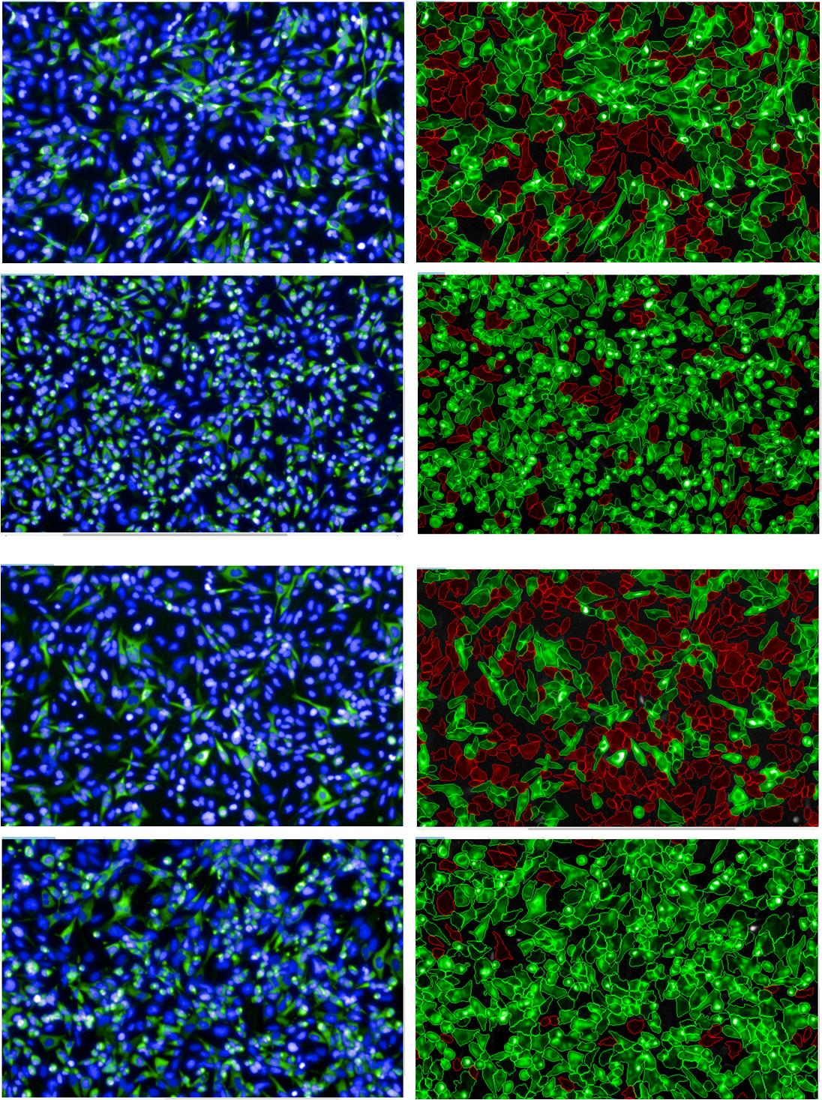

**Original**

**Processed**

**4hpi**

**Asynchronized**

**62.2%**

**B**

**A**

**6hpi**

**84.6%**

**D**

**C**

**4hpi**

**Cold synchronized**

**36.1%**

**F**

**E**

**6hpi**

**93.4%**

**H**

**G**

**Figure 3. Comparing the percentages of infection with and without the cold synchronised infection protocol.** (A-D) Without the cold synchronisation, approximately 62% of cells are infected after 4hpi, which increases to 85% 2hours later. (E-H) When the cold synchronised infection protocol was used when infecting cells, approximately 36% of cells were infected at 4 hpi, but this increased to 93% at 6 hpi.

3.1.2 Selection of timepoints

During the infection of EV-A71 on its host cells, there are certain processes that are crucial, namely the entry, translation, replication of viral RNA, packaging of virions, and release of the infectious particles. For each of these steps, the virus would rely on certain host factors. As translation is particularly important for an RNA virus like EV-A71, we tried to identify timepoints that may be relevant from a translation point of view. This involved looking at changes in the proteins and RNA. In addition, we also looked at the progression of amount of infectious particles.

A protein blot was done to follow the changes in amount of viral proteins produced, as shown in figure 4A. Lysates were collected in hourly intervals after infection, and prepared for doing the gel accordingly. Here, the timepoints can be roughly subdivided into three sections, the early, middle and late timepoints: in the early timepoints (1-3 hpi), most of the bands are not present, in the middle timepoints (4-6 hpi), the four main bands are clearly present for the most part, and finally the late timepoints (7 hpi onwards), where there appears to be other intermediate bands between 36 kDa and 95 kDa.

A qRT-PCR reaction was set up to observe the changes in amount of both positive and negative sense RNA in infected cells. Based on the relative normalised expression against actin, there again appears to be roughly three sections, although the specific timepoint may differ. As shown in figure 4B, there appears to be an early timepoint where most of the viral RNA remains low, a middle timepoint where there is an increase in the amount of viral RNA made, for both the positive and negative sense, and the late timepoint, where the amount of viral RNA decreases, possibly due to the release of virions into the cytoplasm.

To follow the amount of infectious particles, a growth kinetics assay was done, as shown in figure 4C. This showed a similar trend to that of the protein blot and the qRT-PCR graphs: an early, middle and late timepoint. Again, the early timepoint ended at about 4hpi, and the middle timepoint ended at about 7 hpi, when the dip in infectious particles was observed. Hence, from these three methods, there is fairly strong evidence suggesting at least three different sections, probably corresponding to the translation/ transcription processes of viral RNA, and also the packaging/ release of the virions.

In addition, as we wanted to monitor how translation changes, we used the lysates collected and ran polysome profiles for each of the timepoints. Polysome profiles are absorbance traces of lysates run on a linear sucrose gradient after being subjected to ultracentrifugation. While it is theoretically similar to the ribosome profiling method described previously, it does not involve an RNase I digestion step. Hence, the profiles would show the polyribosome section (also known as polysomes), with each peak corresponding to a specific number of ribosome being bound to an mRNA chain. Based on the results obtained, three timepoints were selected (1 hpi, 6 hpi and 9 hpi) to be used for the first round of libraries. Based on the polysome section of these profiles, it is clear how translation differs for each of these timepoints. With this difference in mind, the digest with RNase I had to be optimised separately for each of these timepoints.

**A**

**B**

**C**

**Figure 4. Selection of certain timepoints for further investigation based on the greatest observable changes. (**A) A protein gel was done using anti-VP2, and 4 main bands can be observed, corresponding to each of the 4 protein forms present in an infected cell, each containing the relevant VP2 protein. (B) A qRT-PCR was set up to follow the changes in amounts of both the positive and negative sense of the viral RNA, using actin mRNA as a control. (C) A growth kinetics plot using the lysates collected from each timepoint, showing the changes in infectious particles formed, represented by the number of plaque forming units (PFU) in the lysates.

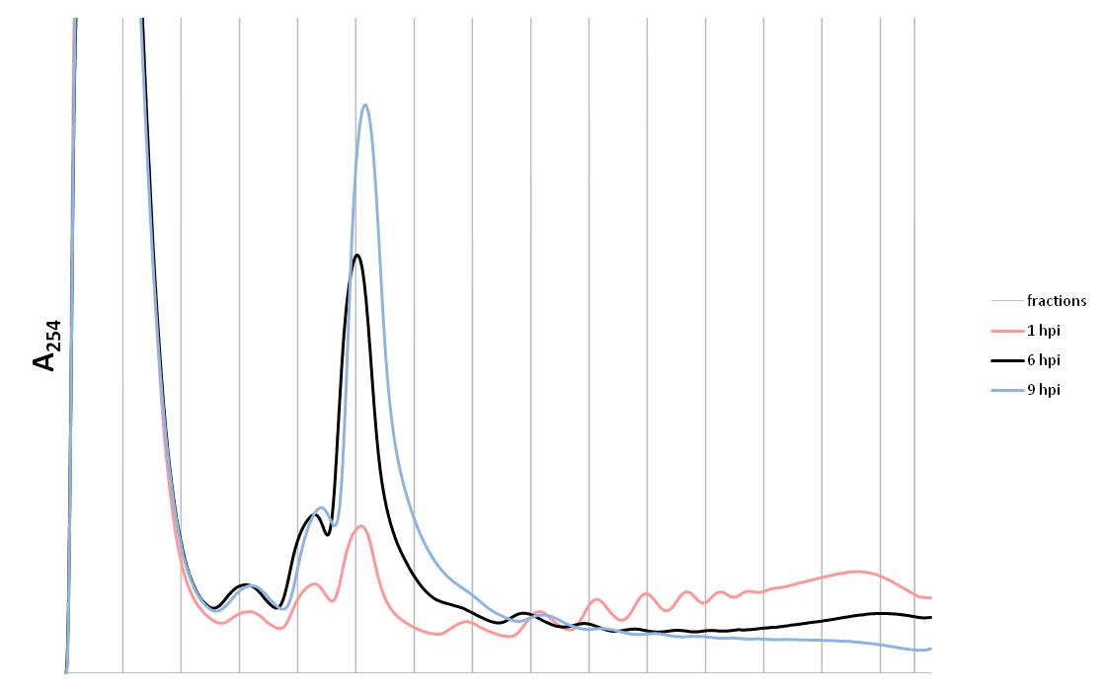

**Figure 5. Polysome profiles for 1, 6 and 9 hours post infection (hpi).** The monosome peak is marked out with the star, and the polysome section is marked out in the bracket.From 1 to 6 to 9 hpi, we see a decrease in the polysome section, indicative of a decrease in overall translation within the cell.

3.1.3 General analysis of ribosome profiling data

From the first set of libraries submitted, an analysis on the quality of library preparation was done. This involved looking at the spread of the read lengths, as well as the periodicity of the reads.

For the libraries submitted, the distributions of read lengths for RPFs are plotted for each of the timepoints. From figure 6A-C, most of the reads fall within the desired range of approximately 30 bases with a good spread, suggesting that the library was prepared correctly. As for the periodicity of the ribosome, although it appears as expected for the 1 hpi library, the 6 and 9 hpi libraries do not follow the usual trend observed in translating ribosomes (figure 6D). However, it is uncertain whether the observed periodicity plot is a real biological phenomenon as a result of the viral infection. Regardless, these libraries can still be used to look at the mRNAs that are being translated, as well as the distribution between host and viral reads. The percentage of reads that are mapped to host mRNA, rRNA and viral RNA are calculated, and follow a somewhat expected trend after infection: an increase in the percentage of reads that map to the viral genome, from 1 hpi to 6 hpi. In addition, the sequences that are mapped to rRNA was used to improve the steps for the next round of library preparation, by designing specific oligos to further deplete the rRNA when performing the subtractive hybridisation step in the library preparation protocol.

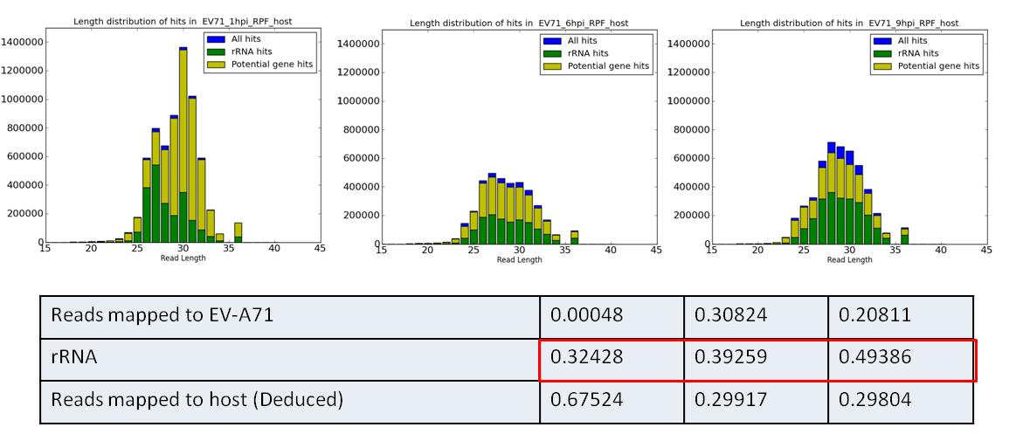

**B**

**A**

**C**

**D**

**Figure 6. Analysis of ribosome profiling data submitted for first set of libraries. (A-C)** Read length distribution for1, 6 and 9 hpi samples respectively. The spread of read lengths was around 30 bases. The distribution of rRNA and mRNA reads are indicated. (D) Periodicity plot for RPF libraries for 1, 6 and 9 hpi, indicating the fraction of reads that begin on the A, P or E sites of the ribosome.

Next, the similarity in the population of mRNAs and RPFs can be compared, by looking at the correlation between the population of mRNAs identified in all 3 timepoints. Using a cut off of 50 reads, scatter plots comparing the timepoints were drawn. As seen from figure 7, there appears to be quite a high correlation of the mRNAs present in all 3 timepoints, be it comparing 1and 6 hpi (figure 7A), 6 and 9hpi (figure 7B), or 1 and 9 hpi (figure 7C).

|  |  |  |  |
| --- | --- | --- | --- |
| **Table 1. Distribution of reads mapped to host mRNA, rRNA and viral RNA.** | 1 hpi | 6 hpi | 9 hpi |
| Reads mapped to EV-A71 | 0.00048 | 0.30824 | 0.20811 |
| rRNA | 0.32428 | 0.39259 | 0.49386 |
| Reads mapped to host mRNA (deduced) | 0.67524 | 0.29917 | 0.29804 |

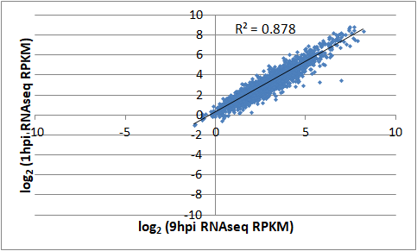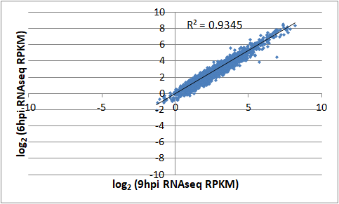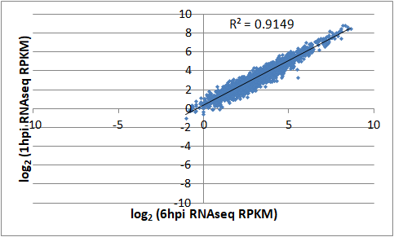

**C**

**B**

**A**

hvs

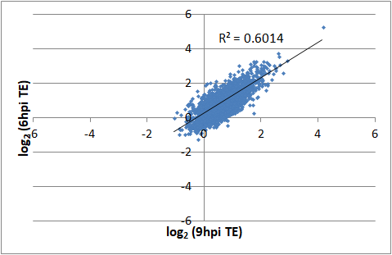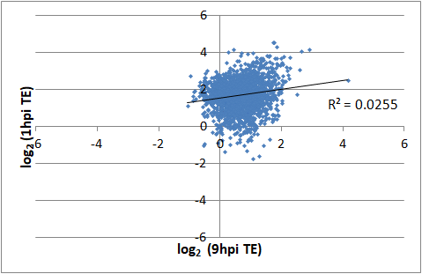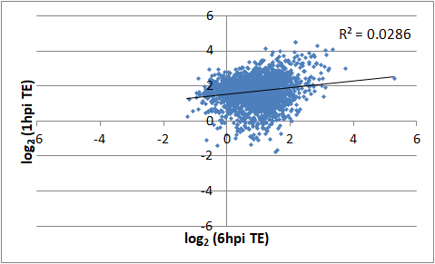

**D**

**E**

**F**

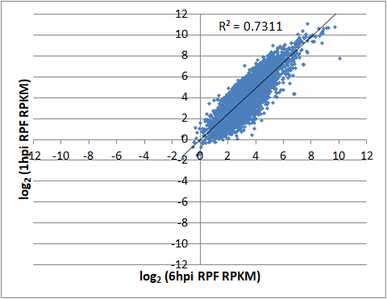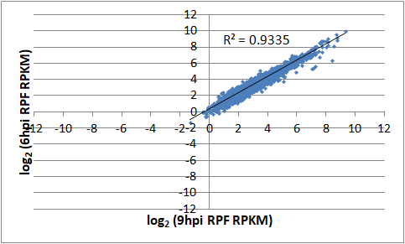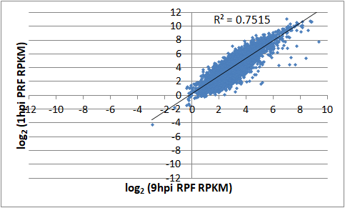

**I**

**H**

**G**

**Figure 7. Comparison of mRNA (RNA-Seq), translation efficiency (TE) and RPFs between all three timepoints used for libraries.** (A-C) High level of correlation between mRNAs present in the cell between all 3 timepoints. (D-F) Low correlation in TE between all three timepoints, suggesting that genes translated at different timepoints are different. There is more correlation in the TE between 6 and 9 hpi. (G-I) A high correlation in the RPFs when comparing the later timepoints of infection, but not between the early and late timepoints.

This correlation, however, is not observed in the TE values (figures 7D - F). This suggests that there may be some form of translational control during infection, regulating which mRNAs are being translated. When comparing solely the reads from RPFs (in figures 7 G - I), it appears that there is a strong correlation between the later parts of infection, suggesting that some host genes affected by viral infection may be translated at both 6 hpi and 9 hpi. However, there is a possibility that these are reads caused by stalling that are absent in the earlier stages of infection. Hence, further testing using harringtonine could be done to check if these are reads from stalled ribosomes, and whether they may be relevant to the replication of the EV-A71 virus.

3.1.4 Preliminary search for hits

Based on previous studies done on viruses, the depletion of certain ribosomal proteins are known to inhibit viral infection, while not having severe effects on the host cell. Also, as translation is an essential process for the replication of the virus, it would be interesting to see how the expression of various translation-related factors is affected during a viral infection.

Looking first at ribosomal proteins in figures 8A and B, in general, it appears that most of them have a lower translational efficiency in the earlier half of infection, but that increases slightly towards the end of infection. However, on the RNA level, there is generally a decrease in the amount of ribosomal protein mRNA as the infection progresses. These suggest that while there is a decrease in the amount of RP mRNA as the infection progresses, the cell may also increase translation efficiency of mRNAs encoding for ribosomal proteins to maintain the number of ribosomes.

Another important group of factors in translation of the EV-A71 RNA is ITAFs (figure 8C and D). In general, it can be seen that these factors have low translation efficiencies throughout the viral infection, suggesting that most of these proteins are synthesised prior to infection, and their translation is decreased as the infection progresses, along with the majority of host genes. On the RNA level, these ITAFs generally change in the earlier part of infection, and remain fairly constant between 6 and 9 hpi. While it has been noted that some ITAFs are especially important for EV-A71 infection, they are not reflected here due to the cut off of 50 reads used (e.g. hnRNP A1, PTBP2, EBP1).

One other group of factors important for translation are eukaryotic initiation factors (eIFs). From the scatter plots in figures 8E, it appears that the translation efficiency generally decreases after the first hour of infection. Some of these factors however, appear to have a slightly higher translation efficiency towards the later half of infection. In general, the trend observed for RPs is similar to that observed for eIFs as well, possibly due to the similar processes that they are involved in.

Translation efficiency

RNA

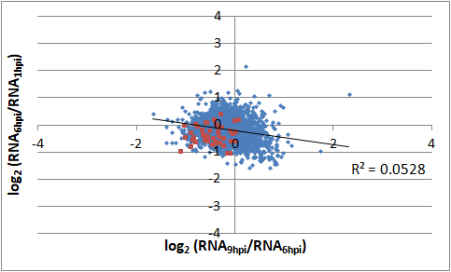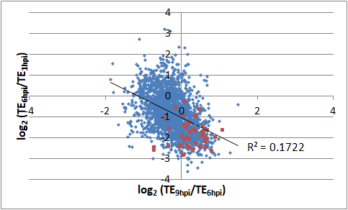

**B**

**A**

Ribosomal Proteins

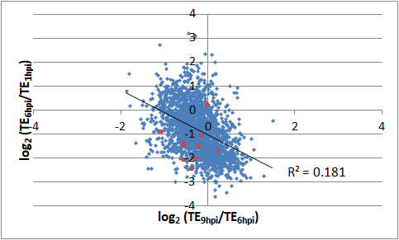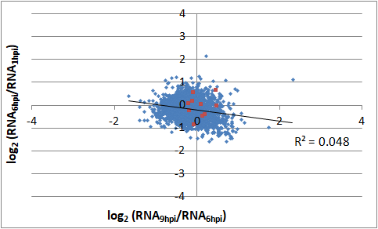hvs

**D**

**C**

ITAFs

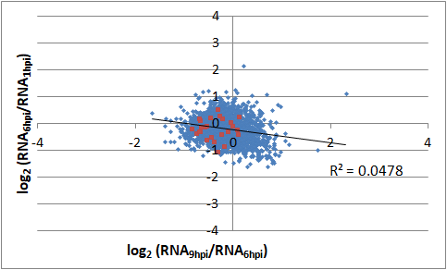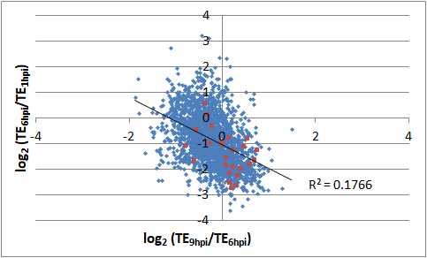

**F**

**E**

eIFs

**Figure 8. Comparing changes in translation (TE) and RNA between early and late halves of infection.** Scatter plots showinglog fold changes between the TEs and amount of RNA in the earlier half and later half of infection. The red dots mark out the TE or RPKM values for (A,B) ribosomal proteins, (C,D) ITAFs, and (E,F) eIFs.

Based on the results observed in the scatter plots above, there does not seem to be any genes in these groups that appear to be strongly regulated at the translational level. However, even if there were, conclusions about specific genes would need further corroboration and functional validation. Hence, the importance of certain biological pathways for the replication of the virus can be investigated.

Using the top and bottom 20% of translated mRNAs based on the TEs and abundance of mRNA, the top and bottom 10 categories of biological processes returned from DAVID are shown here. Looking at the genes on the RNA level, many of the categories correspond to terms containing ribosomal proteins, as well as some initiation factors (for e.g. categories labelled ‘SRP dependent co-translational protein targeting to membrane’, ‘translation initiation’, etc) (Figures 9B, D and F). However, the translation of these ribosomal proteins decreases drastically later into infection, as we look at the bottom 20% of genes that are translated (Figure 10C and E). As for translation in the later part of viral infection, most of the hits come from transcription factors, or factors that interact with the DNA in general (Figures 9C and E). With regards to the relevance of these transcription factors, more work needs to be done to elucidate their role during the infection of an RNA virus.

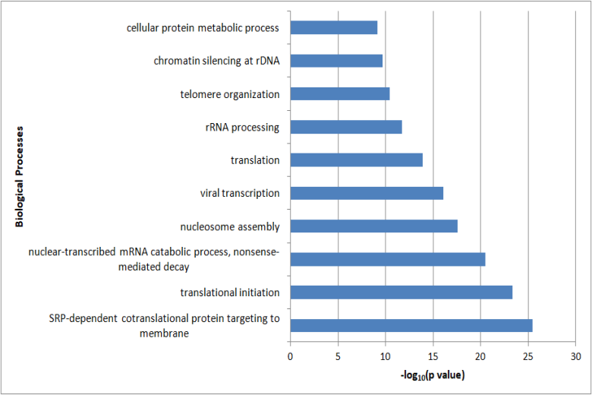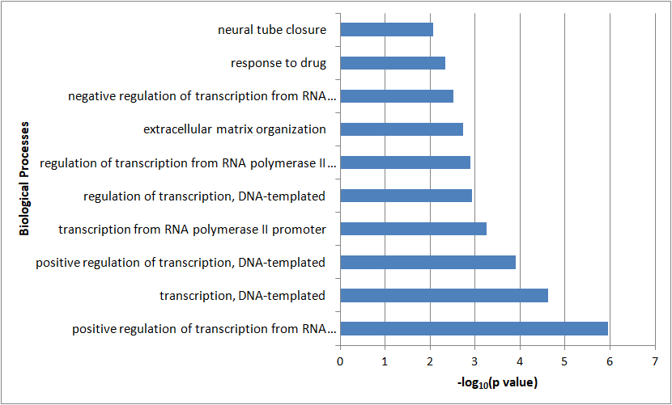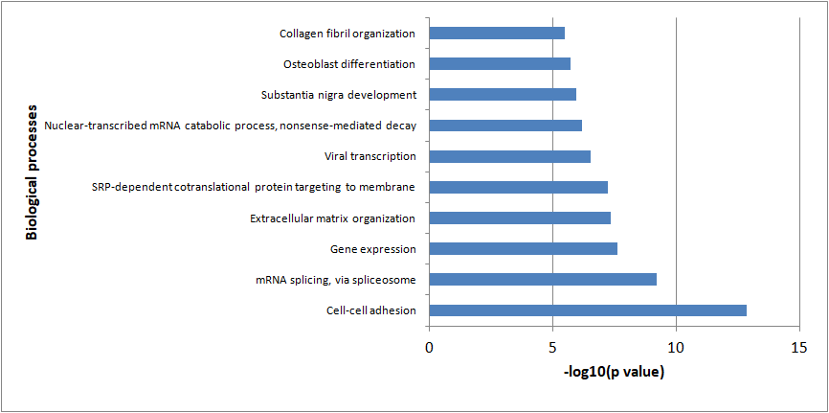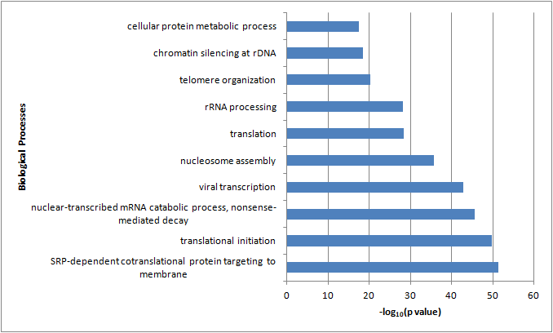

Translation efficiency

RNA

**B**

**A**

1 hpi

**D**

**C**

6 hpi

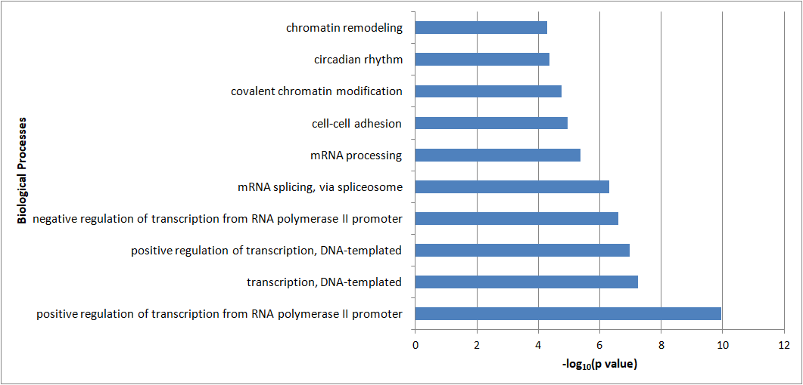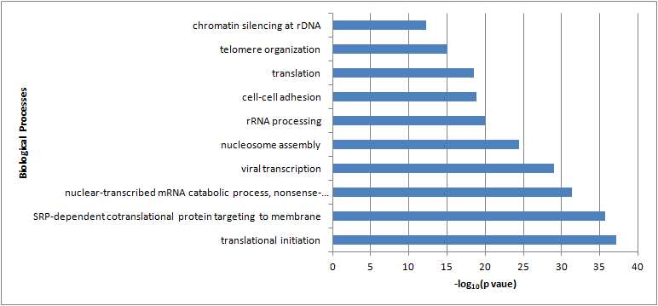

**F**

**E**

9 hpi

**Figure 9. Identification of associated biological processes of the top 20% of reads, based on TE and RNAseq.**

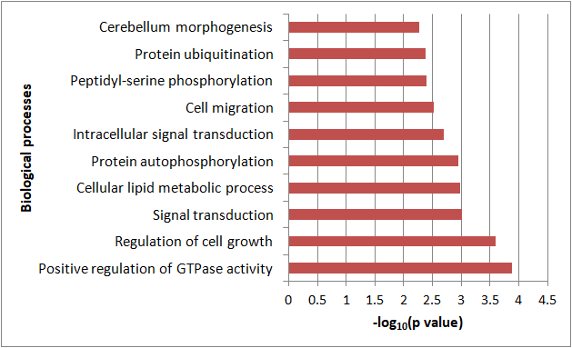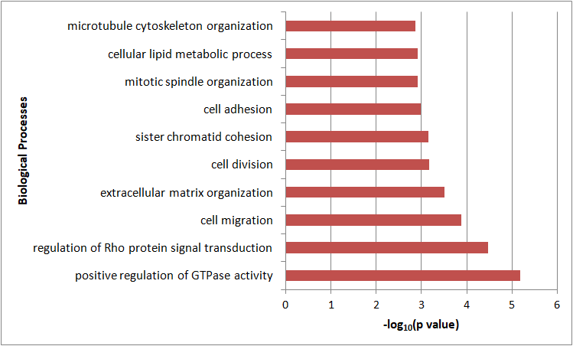

**B**

**A**

Translation efficiency

RNA

hvsh

9 hpi

1 hpi

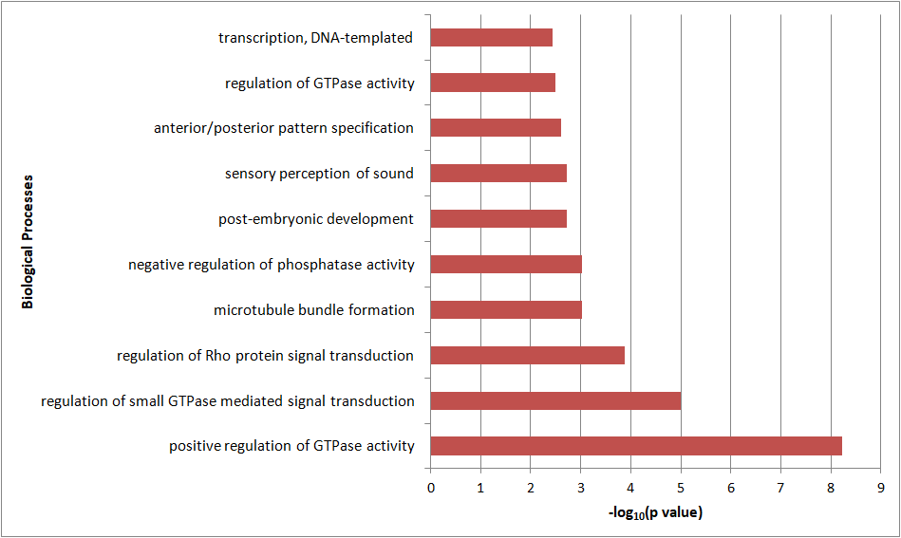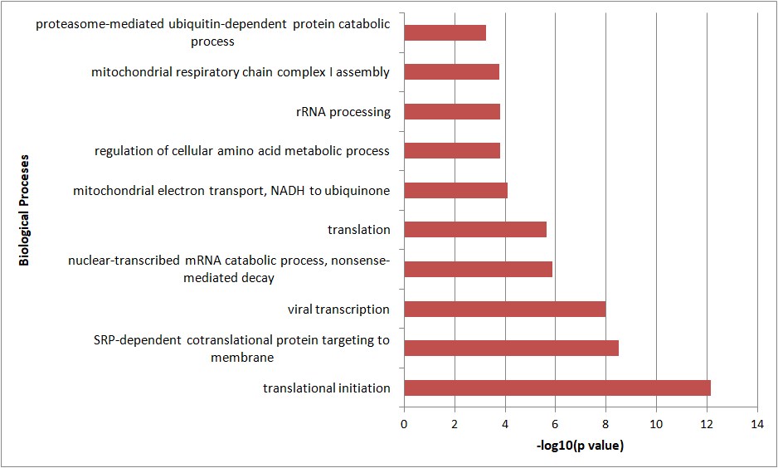

**D**

**C**

6 hpi

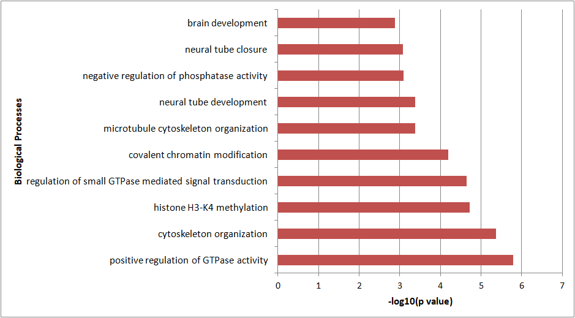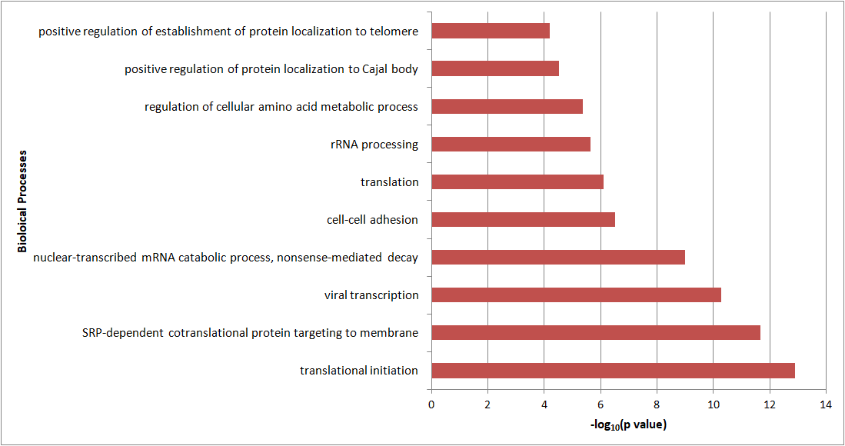

**F**

**E**

**Figure 10. Identification of associated biological processes of the bottom 20% of reads, based on TE and RNAseq.**

1. Future work

4.1 Analysis of results following improved library preparation

Currently, a second set of libraries have been sent for sequencing. Relevant changes were made to the library generation protocol, including the addition of more oligos to further deplete the rRNAs. In addition, lysates from more timepoints were collected in order to be able to observe more closely the changes that occur within two hour intervals post infection.

This additional library would allow us to verify the changes that were observed in the first set of libraries. Then, specific genes can be identified for functional validation. From the first set of libraries, there did not appear to be any specific factors from the three groups highlighted above that varied drastically during the early and late parts of infection. As part of the analysis to be done in future, a threshold can be set, with all genes above or below the threshold being looked at in greater detail.

With specific factors being identified, a functional validation of these factors can then be carried out. A knockdown assay using siRNA can be done, after which the importance of these factors on the infection process can be studied (i.e. the pathways in which these proteins are involved in). At the same time, it would also be necessary to study the effects of knocking down the proteins on uninfected cells.

Along with the paper that was submitted earlier this year, the GEO dataset from their sequencing was also submitted. Hence, part of the work to be done in future would also be to take a look at the changes in their dataset between the three timepoints that they used. However, due to differences in the conditions used, it would not be unexpected to see certain differences in the results as well.

1. References

Alexander, J.P. et al., 1994. Enterovirus 71 infections and neurologic disease--United States, 1977-1991. *The Journal of infectious diseases*, 169(4), pp.905–8.

Baek, K. et al., 2011. Epidemics of enterovirus infection in Chungnam Korea, 2008 and 2009. *Virology Journal*, 8(1), p.297.

Bercovich-Kinori, A. et al., 2016. A systematic view on influenza induced host shutoff. *eLife*, 5, p.e18311.

Chang, L.Y. et al., 1999. Comparison of enterovirus 71 and coxsackie-virus A16 clinical illnesses during the Taiwan enterovirus epidemic, 1998. *The Pediatric infectious disease journal*, 18(12), pp.1092–6.

Colman, H. et al., 2013. Genome-Wide Analysis of Host mRNA Translation during Hepatitis C Virus Infection. *Journal of Virology*, 87(12), pp.6668–6677.

Dai, A. et al., 2017. Ribosome Profiling Reveals Translational Upregulation of Cellular Oxidative Phosphorylation mRNAs during Vaccinia Virus-Induced Host Shutoff G. McFadden, ed. *Journal of Virology*, 91(5), pp.e01858-16.

Fitzgerald, K.D. & Semler, B.L., 2009. Bridging IRES elements in mRNAs to the eukaryotic translation apparatus. *Biochimica et biophysica acta*, 1789(9–10), pp.518–28.

Hayward, J.C. et al., 1989. Outbreak of poliomyelitis-like paralysis associated with enterovirus 71. *The Pediatric infectious disease journal*, 8(9), pp.611–6.

Health, M. of, 2018. *Weekly Infectious Diseases Bulletin*,

Hooi, P.S. et al., 2002. Hand, foot and mouth disease: University Malaya Medical Centre experience. *The Medical journal of Malaysia*, 57(1), pp.88–91.

Huang, C.-C. et al., 1999. Neurologic Complications in Children with Enterovirus 71 Infection. *New England Journal of Medicine*, 341(13), pp.936–942.

Hussain, K.M. et al., 2011. The essential role of clathrin-mediated endocytosis in the infectious entry of human enterovirus 71. *The Journal of biological chemistry*, 286(1), pp.309–21.

Ingolia, N.T. et al., 2009. Genome-wide analysis in vivo of translation with nucleotide resolution using ribosome profiling. *Science (New York, N.Y.)*, 324(5924), pp.218–23.

Kar, B.R., Dwibedi, B. & Kar, S.K., 2013. An outbreak of hand, foot and mouth disease in Bhubaneswar, Odisha. *Indian pediatrics*, 50(1), pp.139–42.

Karunadharma, P.P. et al., 2015. Respiratory chain protein turnover rates in mice are highly heterogeneous but strikingly conserved across tissues, ages, and treatments. *FASEB journal : official publication of the Federation of American Societies for Experimental Biology*, 29(8), pp.3582–92.

Komar, A.A. & Hatzoglou, M., 2011. Cellular IRES-mediated translation: the war of ITAFs in pathophysiological states. *Cell cycle (Georgetown, Tex.)*, 10(2), pp.229–40.

Landry, D.M., Hertz, M.I. & Thompson, S.R., 2009. RPS25 is essential for translation initiation by the Dicistroviridae and hepatitis C viral IRESs. *Genes & development*, 23(23), pp.2753–64.

Lin, H.-Y. et al., 2013. Caveolar endocytosis is required for human PSGL-1-mediated enterovirus 71 infection. *Journal of virology*, 87(16), pp.9064–76.

Lin, J.-Y. et al., 2008. Heterogeneous nuclear ribonuclear protein K interacts with the enterovirus 71 5’ untranslated region and participates in virus replication. *Journal of General Virology*, 89(10), pp.2540–2549.

Lin, Y. et al., 2018. Simultaneous and systematic analysis of cellular and viral gene expression during Enterovirus 71-induced host shutoff. *Protein & Cell*, pp.1–6.

Lin, Y.-W. et al., 2012. Human SCARB2-Mediated Entry and Endocytosis of EV71 L. N. F. Poh, ed. *PLoS ONE*, 7(1), p.e30507.

Lopez-Lastra, M., Rivas, A. & Barria, M.I., 2005. Protein synthesis in eukaryotes: The growing biological relevance of cap-independent translation initiation. *Biological Research*, 38(2–3), pp.121–146.

Ma, E. et al., 2010. Changing epidemiology of hand, foot, and mouth disease in Hong Kong, 2001-2009. *Japanese journal of infectious diseases*, 63(6), pp.422–6.

Meng, T. & Kwang, J., 2014. Attenuation of Human Enterovirus 71 High-Replication-Fidelity Variants in AG129 Mice. *Journal of Virology*, 88(10), pp.5803–5815.

Miwa, C. et al., 1980. Epidemic of hand, foot and mouth disease in Gifu Prefecture in 1978. *Japanese journal of medical science & biology*, 33(3), pp.167–80.

Momoki, S.T., 2009. Surveillance of enterovirus infections in Yokohama city from 2004 to 2008. *Japanese journal of infectious diseases*, 62(6), pp.471–3.

Nishimura, Y. et al., 2009. Human P-selectin glycoprotein ligand-1 is a functional receptor for enterovirus 71. *Nature Medicine*, 15(7), pp.794–797.

Popa-Wagner, A.P.-W. et al., 2018. Increased Degradation Rates in the Components of the Mitochondrial Oxidative Phosphorylation Chain in the Cerebellum of Old Mice. *Frontiers in Aging Neuroscience*, 10, p.32.

Pyronnet, S., Pradayrol, L. & Sonenberg, N., 2000. A cell cycle-dependent internal ribosome entry site. *Molecular cell*, 5(4), pp.607–16.

Sasidharan, C.K. et al., 2005. Hand-foot-and-mouth disease in Calicut. *Indian journal of pediatrics*, 72(1), pp.17–21.

Shatsky, I.N. et al., 2010. Cap- and IRES-independent scanning mechanism of translation initiation as an alternative to the concept of cellular IRESs. *Molecules and Cells*, 30(4), pp.285–293.

Shih, S.-R., Stollar, V. & Li, M.-L., 2011. Host Factors in Enterovirus 71 Replication. *Journal of Virology*, 85(19), pp.9658–9666.

Wang, Y. et al., 2013. Epidemiology and clinical characteristics of hand foot, and mouth disease in a Shenzhen sentinel hospital from 2009 to 2011. *BMC infectious diseases*, 13, p.539.

Wong, S.S.Y. et al., 2010. Human enterovirus 71 and hand, foot and mouth disease. *Epidemiology and Infection*, 138(8), pp.1071–1089.

Wu, Y. et al., 2010. The largest outbreak of hand; foot and mouth disease in Singapore in 2008: The role of enterovirus 71 and coxsackievirus A strains. *International Journal of Infectious Diseases*, 14(12), pp.e1076–e1081.

Yamayoshi, S. et al., 2009. Scavenger receptor B2 is a cellular receptor for enterovirus 71. *Nature Medicine*, 15(7), pp.798–801.

Yamayoshi, S., Fujii, K. & Koike, S., 2014. Receptors for enterovirus 71. *Emerging microbes & infections*, 3(7), p.e53.

Yang, Z. et al., 2015. Deciphering Poxvirus Gene Expression by RNA Sequencing and Ribosome Profiling G. McFadden, ed. *Journal of Virology*, 89(13), pp.6874–6886.

Yi, E.-J. et al., 2017. Enterovirus 71 infection and vaccines. *Clinical and experimental vaccine research*, 6(1), pp.4–14.

Zhao, J. et al., 2016. Age patterns and transmission characteristics of hand, foot and mouth disease in China. *BMC infectious diseases*, 16(1), p.691.

Zhou, F. et al., 2011. Molecular characterization of enterovirus 71 and coxsackievirus A16 using the 5’ untranslated region and VP1 region. *Journal of Medical Microbiology*, 60(3), pp.349–358.